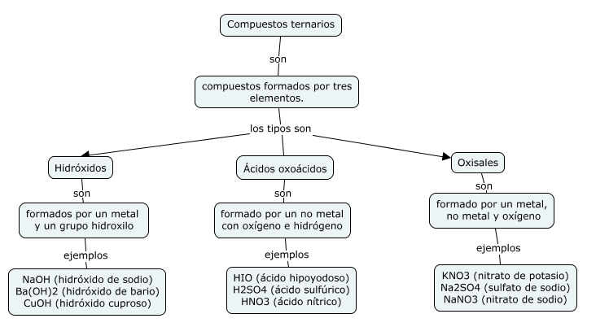Robert Lu Zheng 3–750-1980 | 1IL112